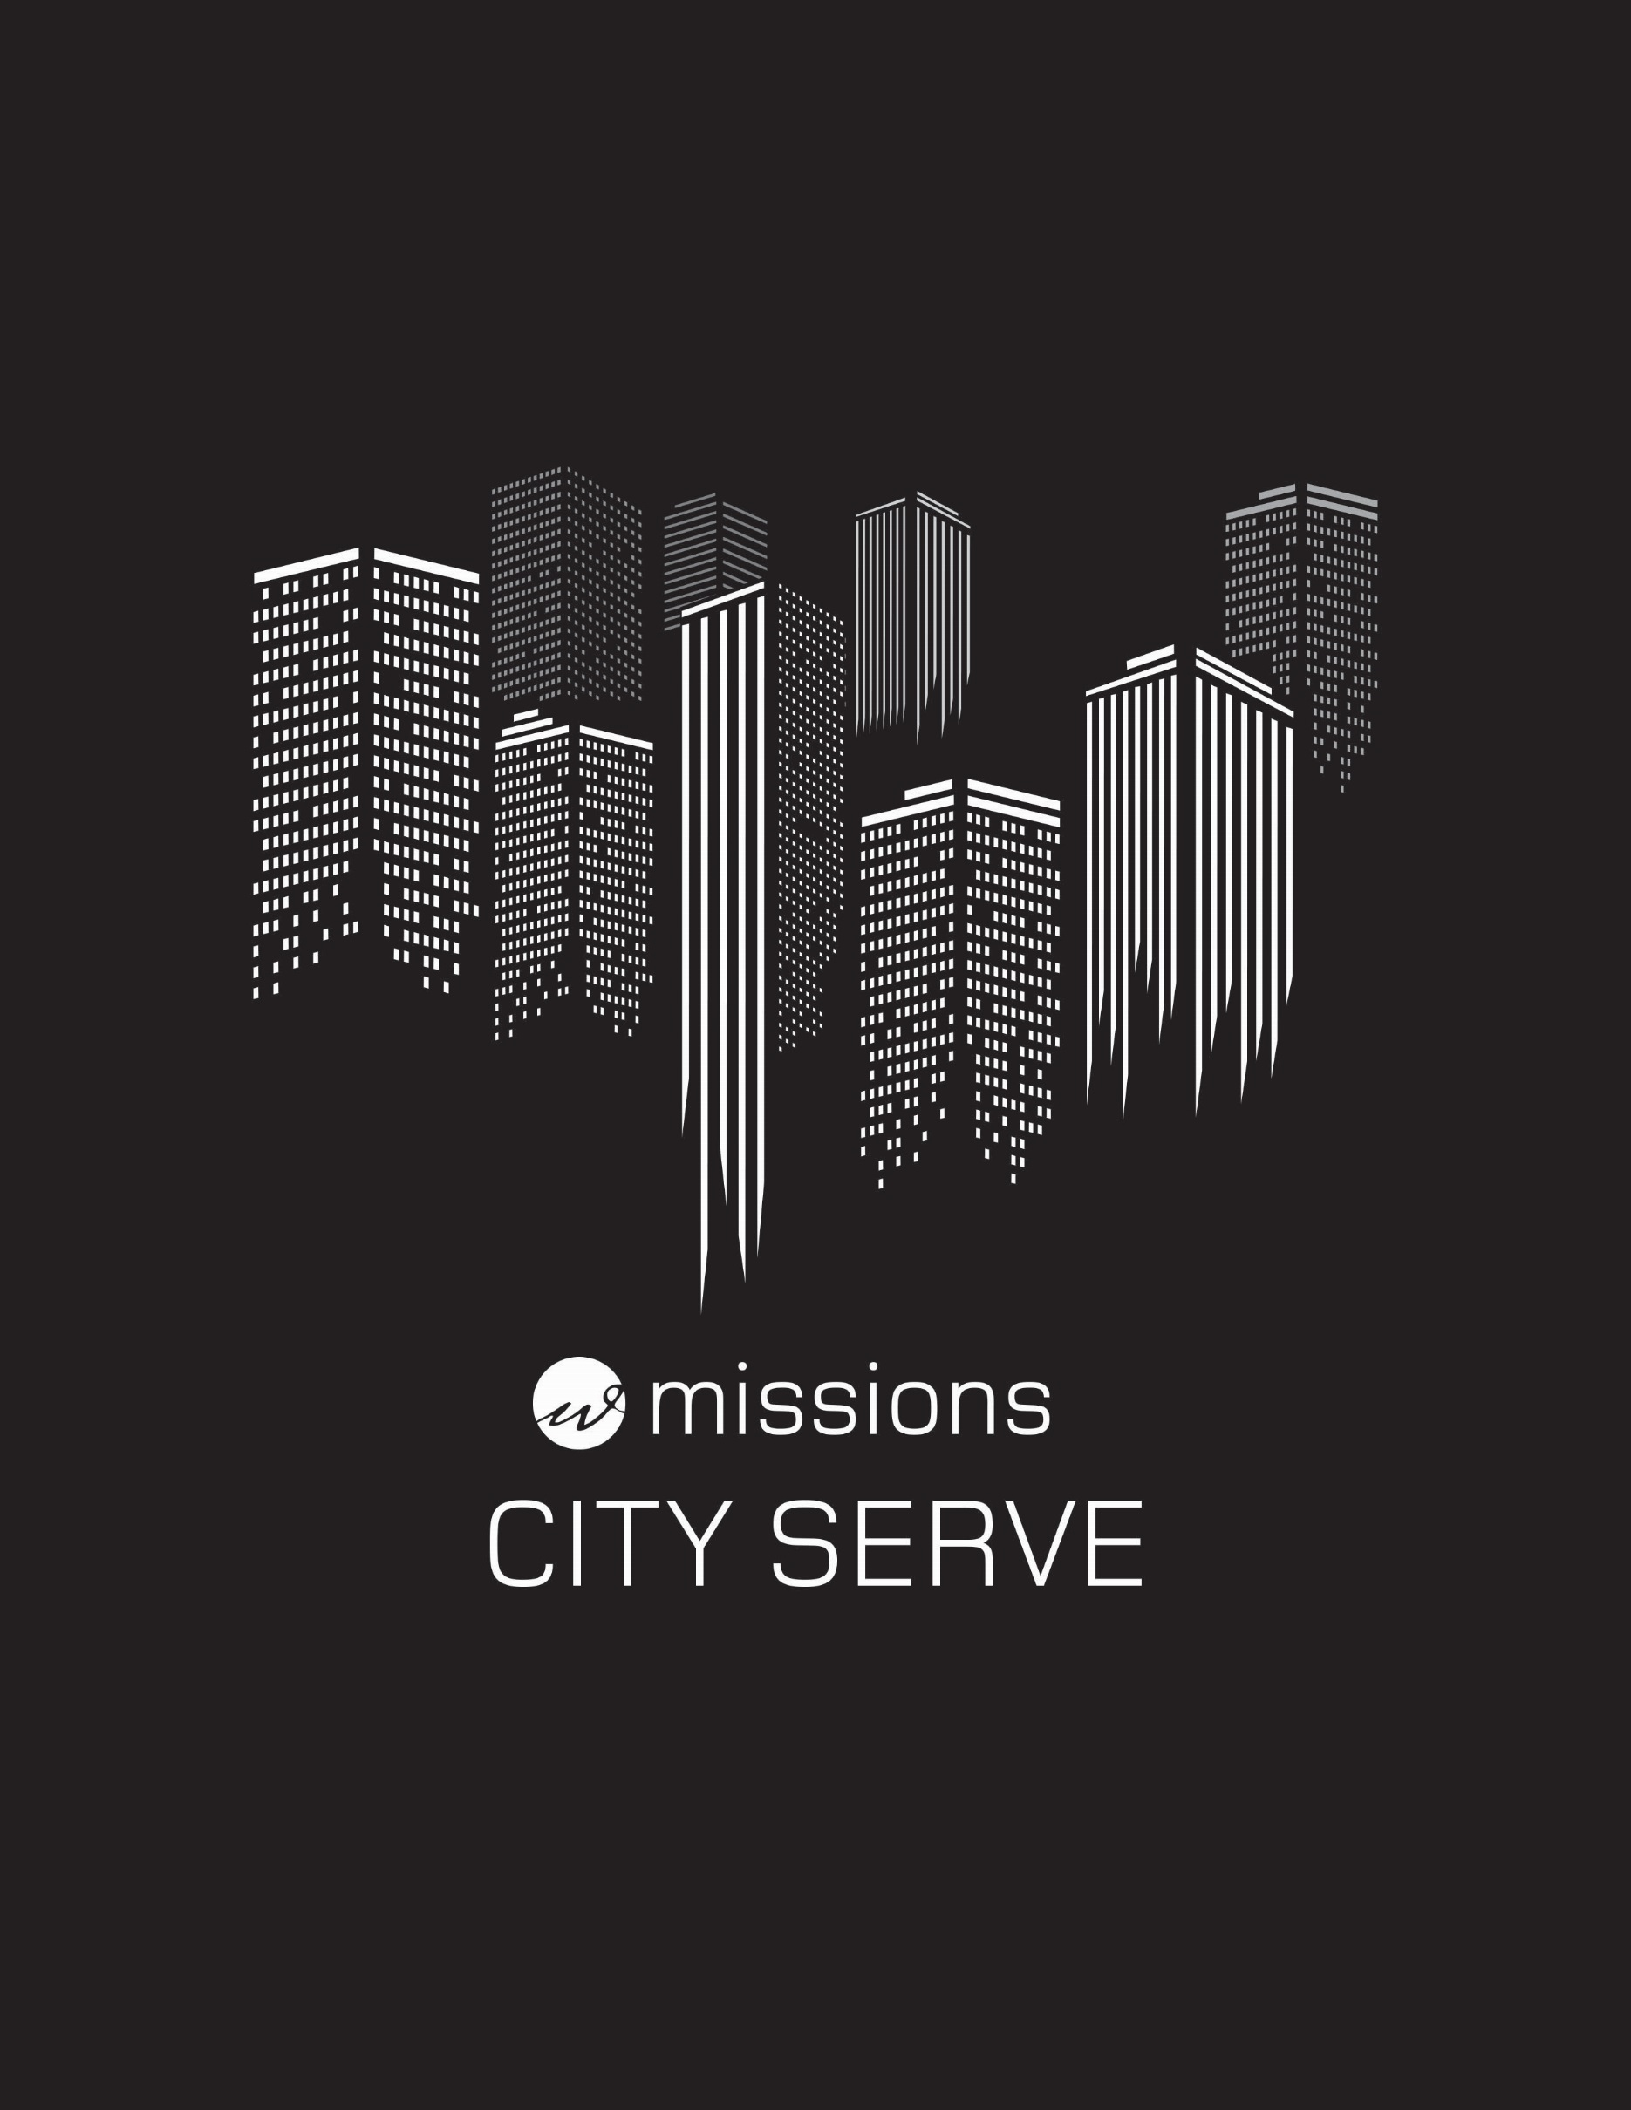
City Serve
Dates: June 17-20th

Where: Locally

Cost: $150

The Context:
This year, we will be starting a new mission trip around the city. We will be working with a few of Waterstone’s partnered ministries for a chance to see how God is working in our city and through these ministries. Students will get the chance to get involved with these organizations and help with various projects.
What will we be doing?
We will be working with some of Waterstone’s partnered ministries and will be assisting them in different projects throughout Monday and Tuesday. There will be opportunities for community involvement through a poverty scavenger hunt and various other activities, and possible tours of different ministries.
Our Mission:
Our mission is to come alongside partner ministries that are serving our local community to assist them and learn about what they are doing to impact those in need. While we only have a few days to do this, we hope to offer support to these ministries.
Important Dates:
May 28th: $50 Deposit due
June 11th: All Funds Due- $150
June 17th: First day of City Serve
June 20th: Last day of City Serve

Where do we stay?
We have reserved rooms at Waterstone and will be showering at the Ridge Recreation Center.
Schedule:
Sunday, June 17th
4:00 PM Arrive at Waterstone and unpack
6:00 PM Dinner
7:30 PM Showers at the Ridge
11:00 PM Lights Out
Monday, June 18th
7:30 AM Breakfast
9:00 AM First service project -TBD
12:00 PM Lunch
1:00 PM Second service project -TBD
6:00 PM Dinner
7:30 PM Showers at the Ridge
8:30 PM Debrief
11:00 PM Lights Out
Tuesday, June 19th
7:30 AM Breakfast
9:00 AM First service project -TBD
12:00 PM Lunch
1:00 PM Second service project with -TBD
6:00 PM Dinner
7:30 PM Showers at the Ridge
8:30 PM Debrief
11:00 PM Lights Out
Wednesday, June 20th
7:30 AM Breakfast
8:00 AM Pack & Clean

Packing List
Toothbrush, toothpaste, deodorant, toiletries
Sunscreen & sun glasses
Soap & shampoo
Sleeping Bag
Towels, washcloths
Water bottle
Bible, journal, pens
Spending money (optional)
Work gloves
Work cloths (long pants)
Shorts and t-shirts
Tennis shoes/work shoes
Swim suit

